**1. Mục đích bài viết**

* This article will guide in detail the configuration of the Palo Alto Networks firewall device to allow users within the LAN to access over the Internet..

**2. Network diagram, configuration situation and steps to be taken.**

**2.1 Network digram :**

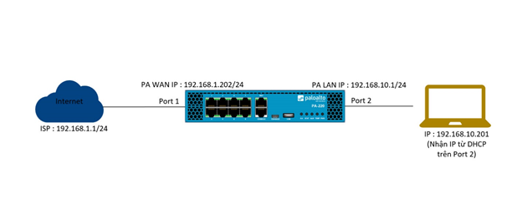

**2.2 Detailed network diagram :**

* As the diagram, the Palo Alto firewall device will be connected to the internet in port 1 with a static IP of 192.168.1.202/24 and point to the gateway that is the address of the network 192.168.1.1/24.
* On the inside of Palo Alto is the intranet layer with IP 192.168.10.1/24 set to port 2. On port 2 is configured DHCP server to allocate IP for devices accessing it.
* Finally, a Laptop device is connected to port 2 via a network cable and receives IP 192.168.10.201 from the DHCP server on port 2.

**2.3 Configuration steps :**

* Connect to the admin site of the firewall device.
* Create zone.
* Create Interface Mgmt Profile.
* Network port configuration.
* Create Virtual Router.
* DHCP Server configuration.
* Create NAT policy.
* Create Security Policy Rule.
* Result

**3. Configuration guide.**

**3.1 Connect to the admin site of the firewall device .**

* We will connect to the firewall administration page using a network cable connecting the computer to the MGMT port of the Palo Alto firewall.
* Open the browser and access by the link https://192.168.1.1. The default account and password for the Palo Alto firewall are admin – admin.

**3.2 Create zone**

* We will create two zones, WAN and LAN.
* To create a WAN zone go to Network > Zones > click Add, enter the following information :
  + Name : WAN
  + Type : Layer 3
* Click OK to save.

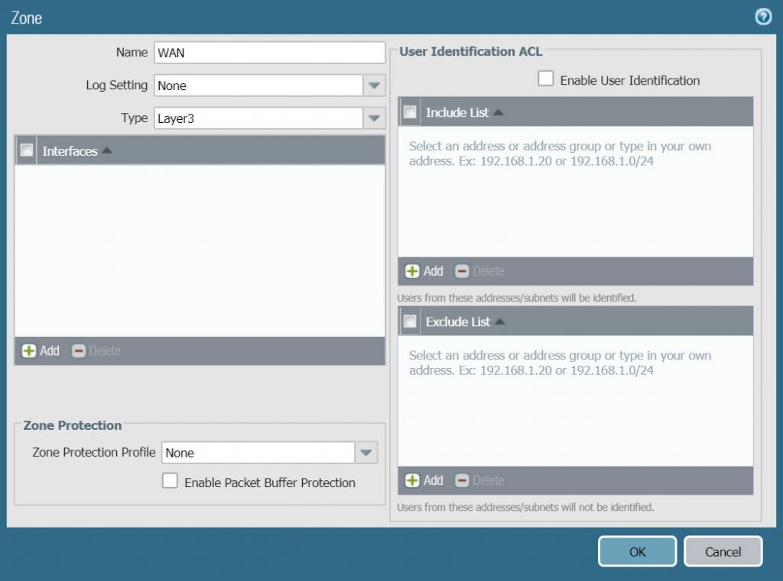

* Similarly click Add to create a LAN zone with the following parameters :
  + Name : LAN
  + Type : Layer 3
* Click OK to save.

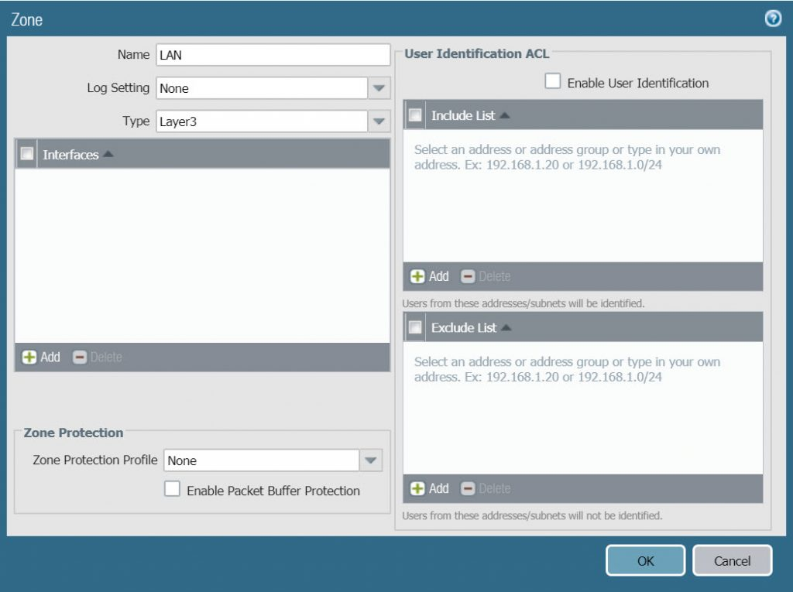

**3.3 Create Interface Mgmt File**

* The purpose of creating Interface Mgmt profile is to open some essential services for any network port such as HTTPS, Ping …
* Here we will create an Interface Mgmt Profile that allows HTTPS, Ping, SSH, Reponse Pages services for 1/2 ethernet LAN port so we can ping, access the admin site on this port without connecting by Mgmt port.
* To create Interface Mgmt Profile go to Network> Interface Mgmt> click Add and enter the following parameters :
  + Name : ping-reponse-pages
  + Administrative Management Services : select HTTPS, SSH.
  + Network Services : select ping và reponse pages.
* Click OK to save.

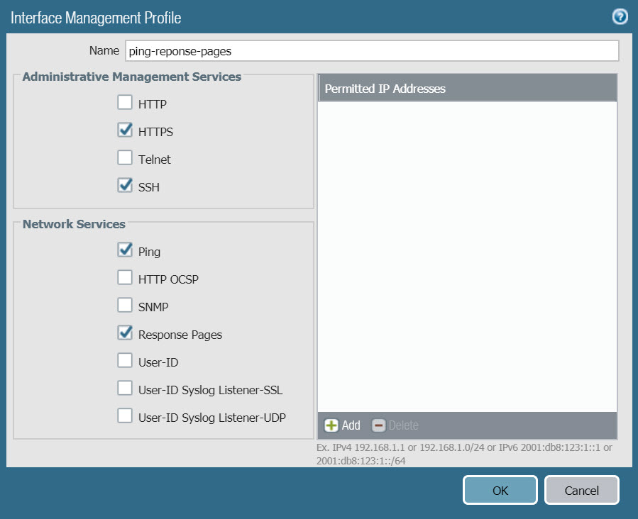

**3.4 Network port configuration**

* To configure ethernet1/1 network port go to Network > Interfaces > click on the network port name.
* In the Config tab, configure the following parameters :
  + Interface type : select Layer 3
  + Security Zone : select WAN

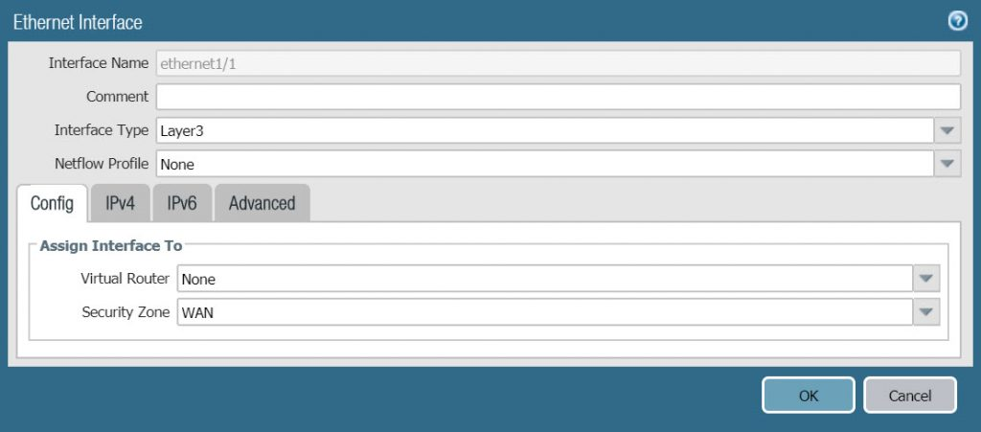

* In the IPv4 tab, configure according to the following parameters :
  + Type : select Static
  + Click Add và type IP address 192.168.1.202/24.
* Click OK to save.

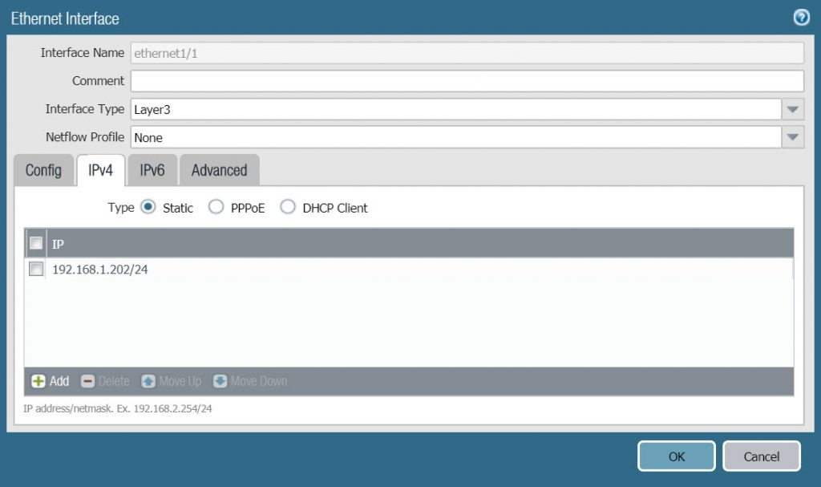

* Similar to ethernet1/1 port, to configure ethernet1/2 port click on the port name.
* In the Config tab, configure according to the following parameters :
  + Interface Type : Layer 3
  + Security Zone : LAN

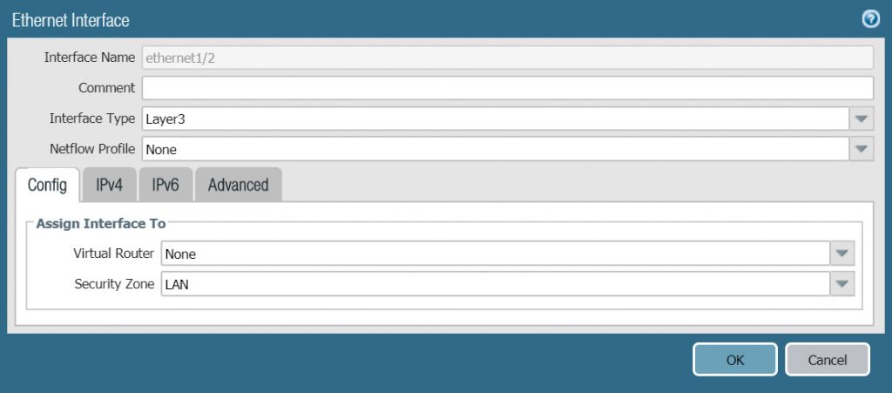

* In the IPv4 tab, we configure the following parameters :
  + Type : Static
  + Click Add và type IP 192.168.10.1/24

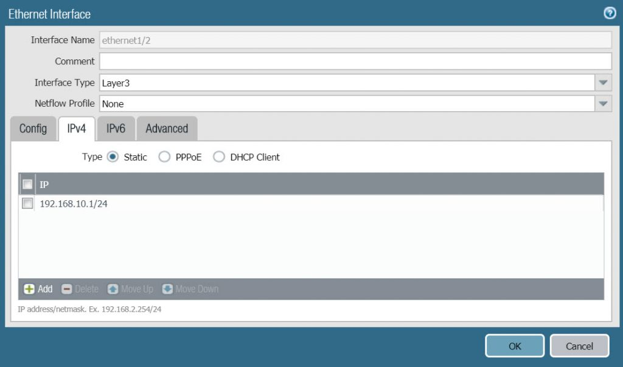

* In the Advanced tab, configure the following :
  + In Other Info > Management Profile select the ping-reponse-pages we just created in the previous section.

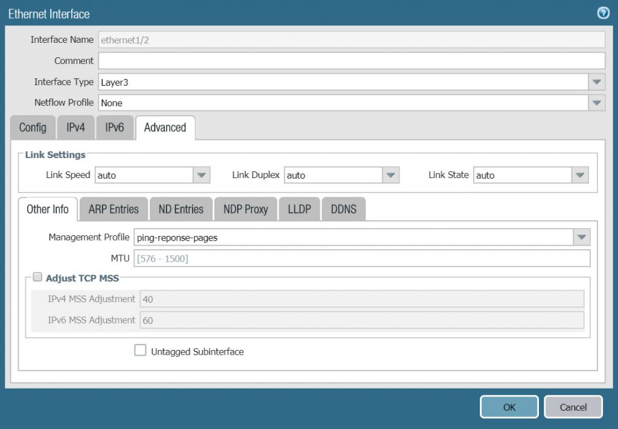

**3.5 Create Virtual Router**

* To create a Virtual Router go to Network > Virtual Router > Click Add.
* In the Router Settings tab, configure according to the following parameters :
  + Name : VR1
  + In the General panel, click Add and add 2 port ethernet1/1 and Ethernet1/2.
* On the Static Routes tab, click Add and configure according to the following parameters :
  + Name : default-route
  + Destination : 0.0.0.0/0
  + Interface : ethernet1/1
  + Next Hop : IP Address and enter 192.168.1.1 in the box below.

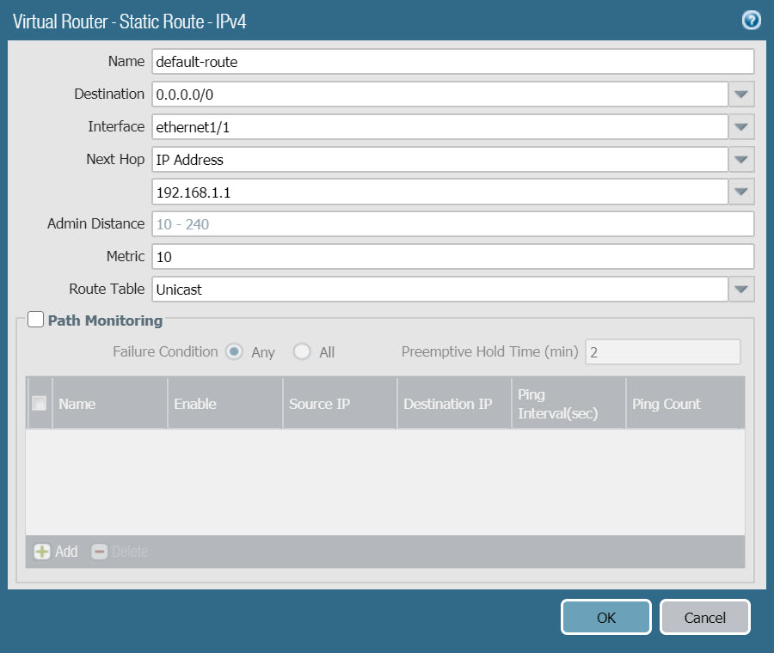

* Click OK two time to save.

**3.6 DHCP Server configuration**

* To configure DHCP Server go to Network > DHCP > click Add.
* In the Lease tab, configure with the following parameters :
  + Interface : select ethernet1/2
  + Mode : enable
  + In the IP Pools table click Add and fill in the IP range that will be allocated as 192.168.10.200-192.168.10.230.

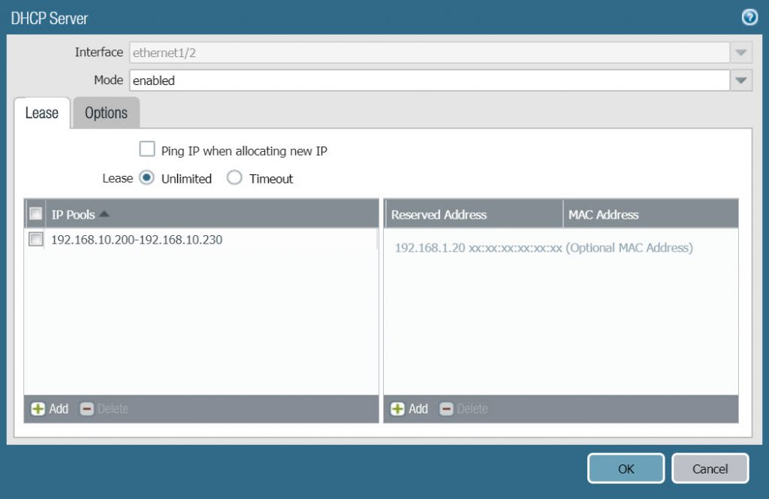

* In the Options tab, configure with the following parameters :
  + Gateway : 192.168.10.1
  + Subnet Mask : 255.255.255.0
  + Primary DNS : 8.8.8.8
  + Secondary DNS : 8.8.4.4

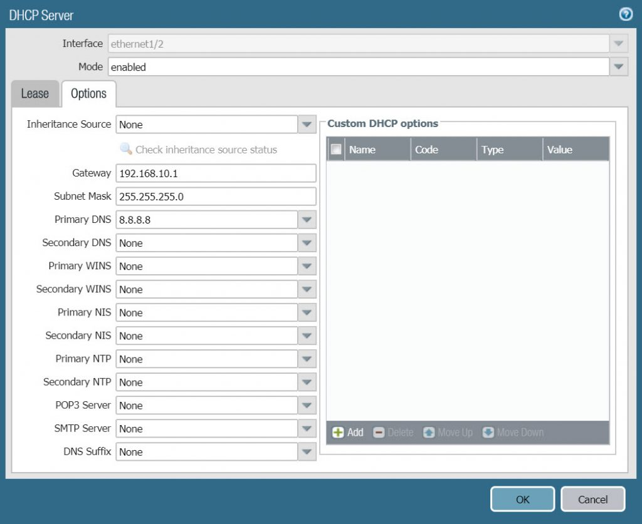

* Click OK to save.

**3.7 Create NAT Policy**

* To create NAT Policy go to Policies > NAT > Click Add.
* In the General tab, configure according to the following parameters :
  + Name : LAN_TO_WAN
  + NAT Type : ipv4

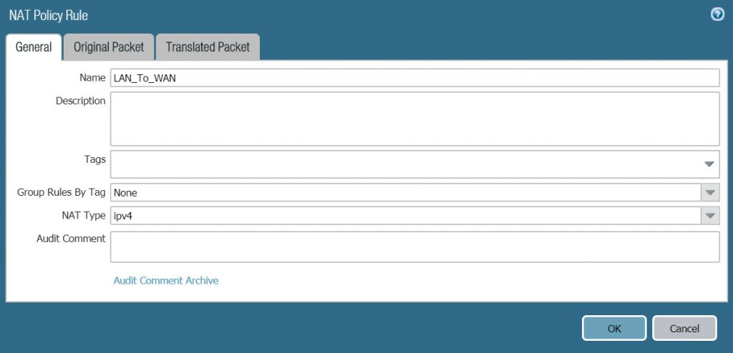

* In the Original Packet tab, configure according to the following parameters :
  + Source Zone : LAN
  + Destination Zone : WAN
  + Destination Interface : ethernet 1/1

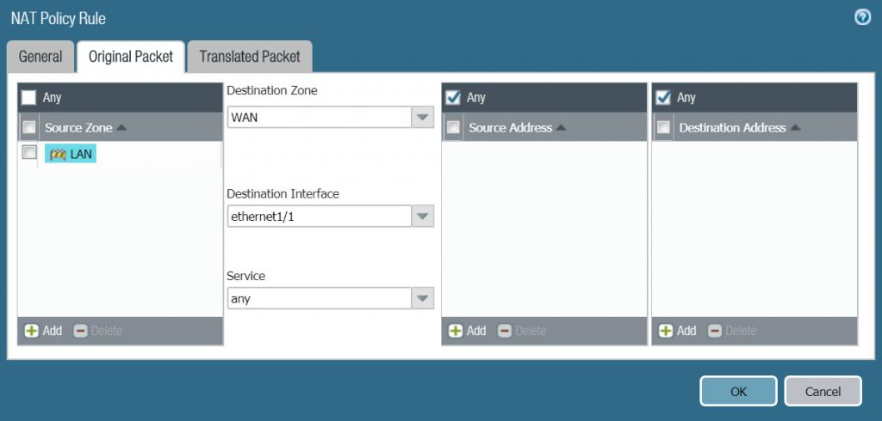

* In the Translated Packet tab > Source Address Translation, configure the following parameters :
  + Translation Type : Dynamic IP and Port
  + Address Type : Interface Address
  + Interface : ethernet1/1
  + IP Address : 192.168.1.202/24 (Note that this location must be selected from the drop down list, not entered manually)

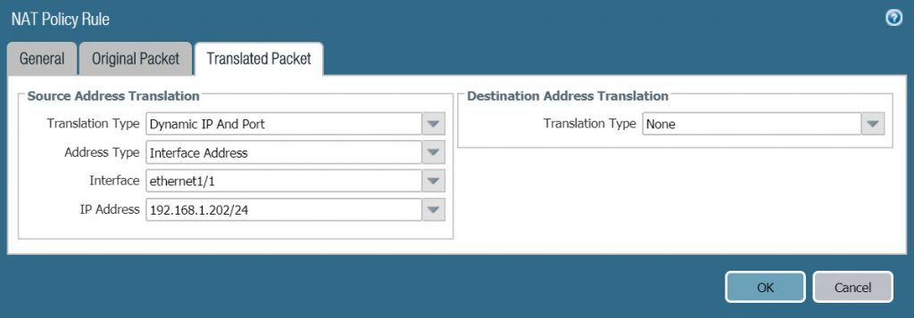

**3.8 Create Security Policy Rule**

* To create Policies > Security > Click Add.
* In the General tab, configure according to the following parameters :
  + Name : Access_Internet
  + Rule Type : universal (default)

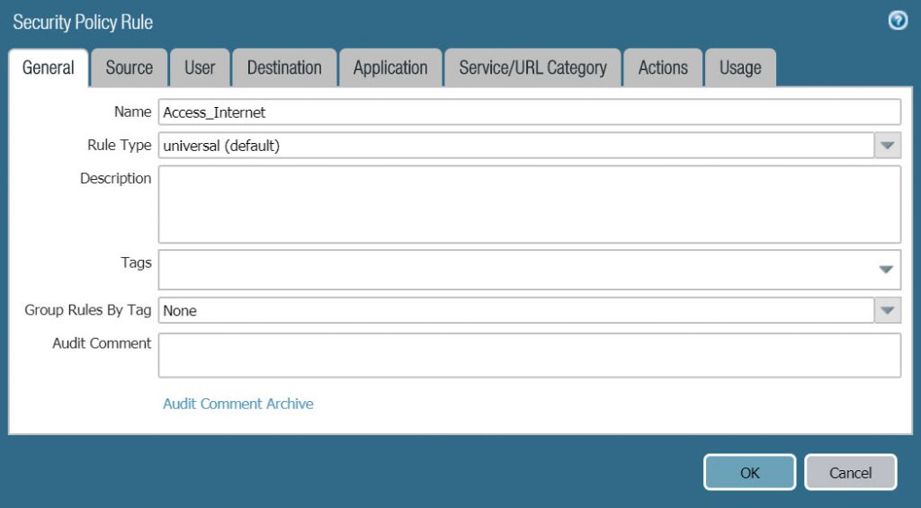

* On the Source tab, select LAN in Source Zone.

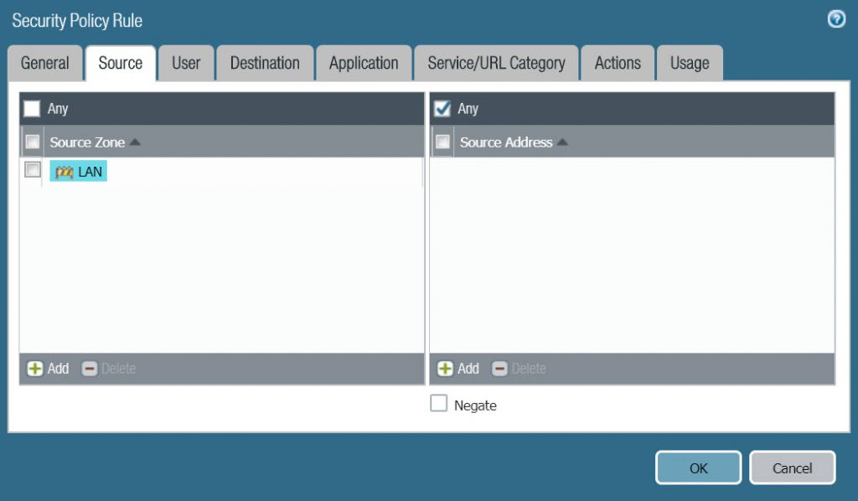

* On the Destination tab, choose WAN in Destinatoin Zone.

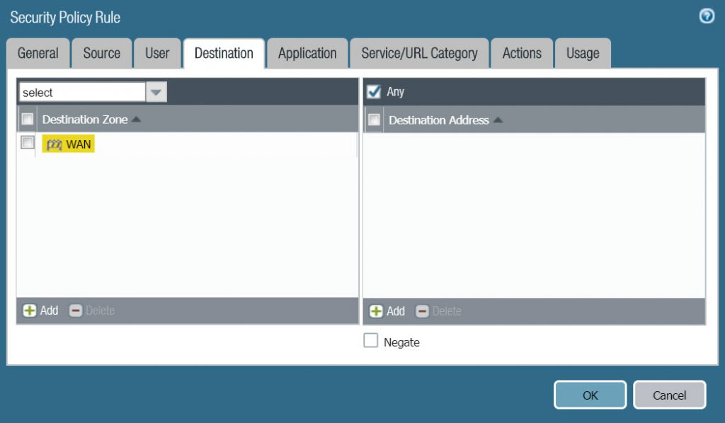

* On the Application tab, select Any.

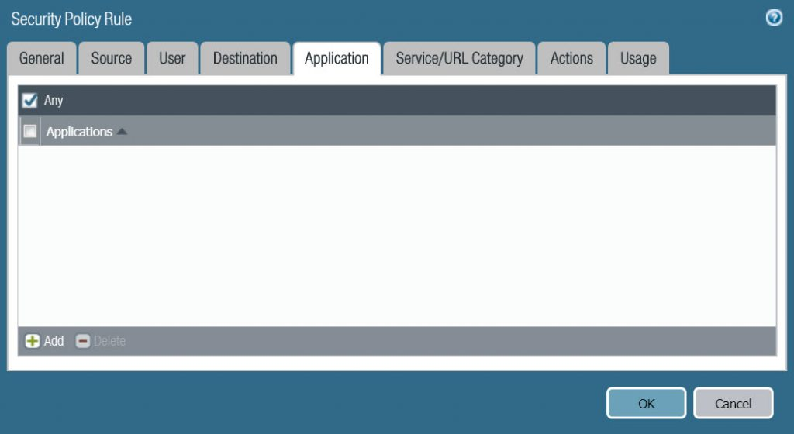

* On the Service / URL Category tab, select any.

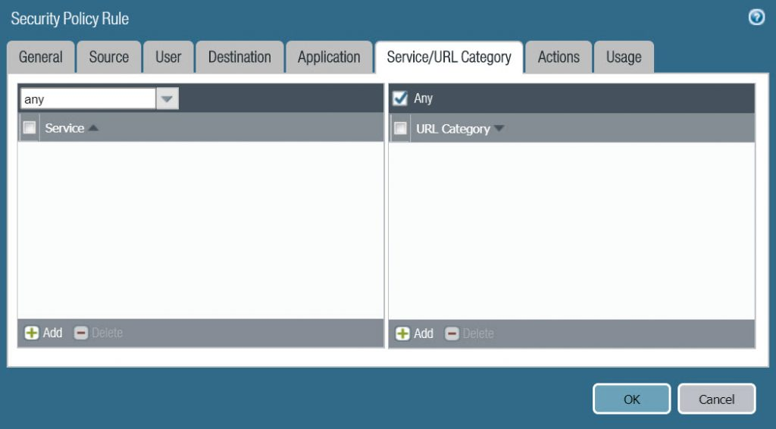

* In the Action tab, configure the following :
  + Action Setting : Allow
  + Log Setting : Log at Session End.

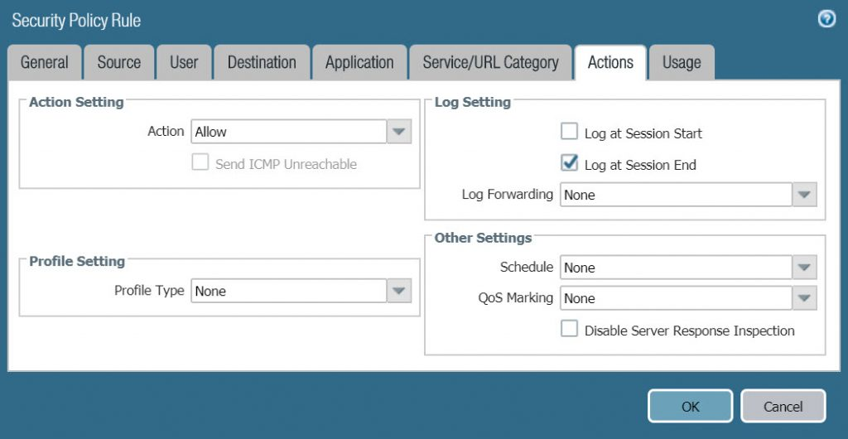

* Click OK to save.